# Covariance

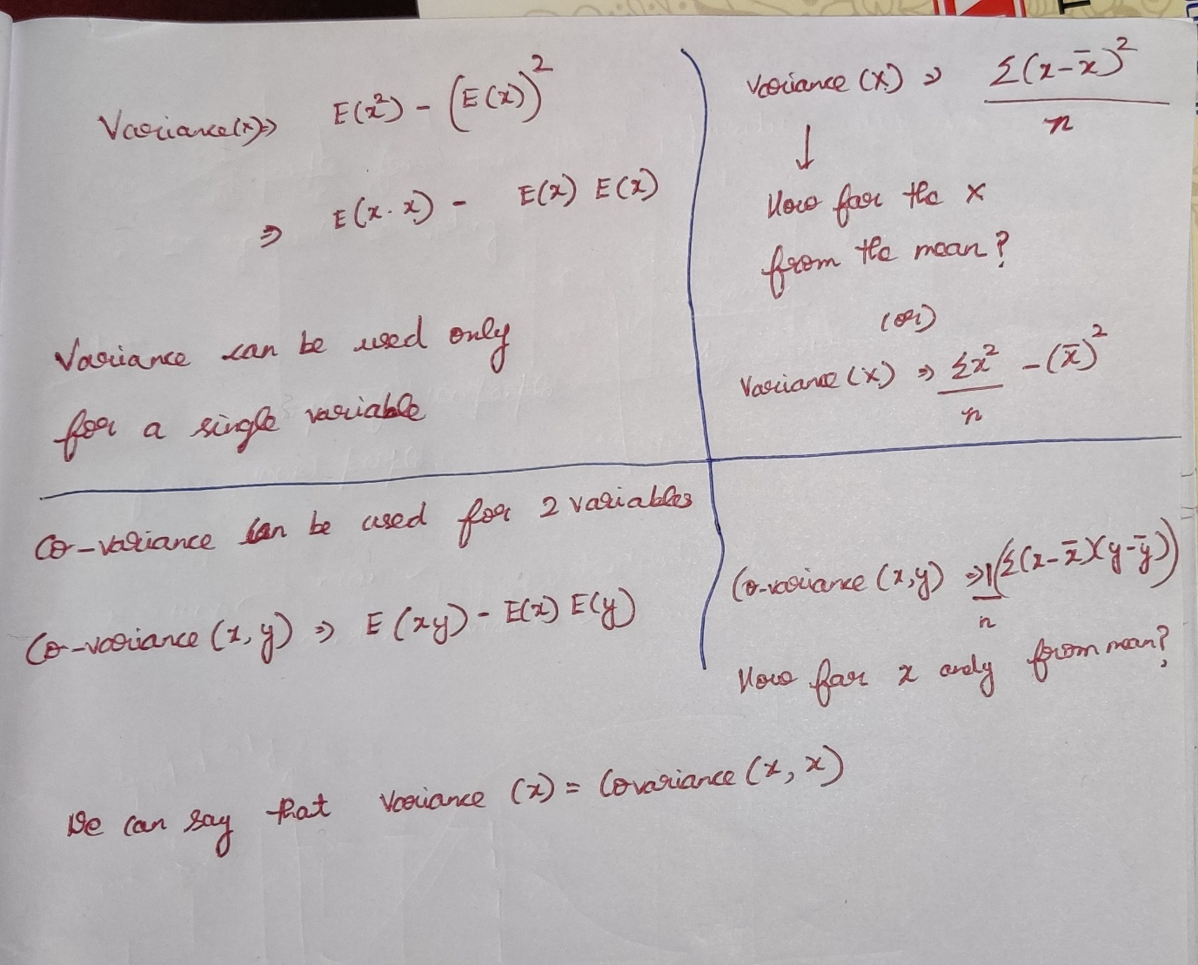

when **Covariance(x,y) = 0**, the two independent variables are un-correlated.

***Covariance 🡪 Only direction (+ve direction / -ve direction)  
Correlation 🡪 Magnitude with direction ( how much +ve / how much -ve)***

With covariance we cannot able to determine the strength of relationship between 2 variables, we can say only these two variables are dependent to each-other.

With correlation we can able to determine the strength of the relationship.

# Karl Pearson Correlation / Correlation

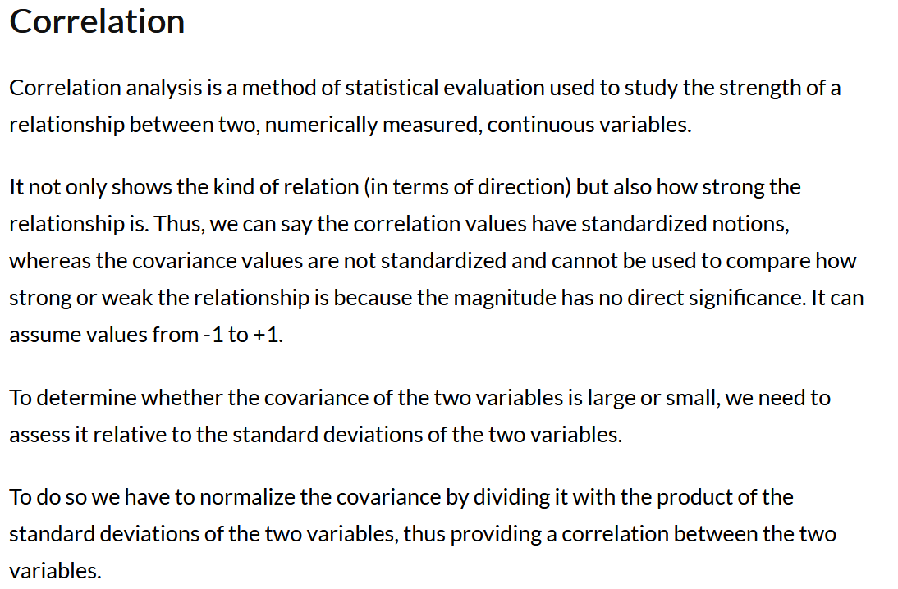

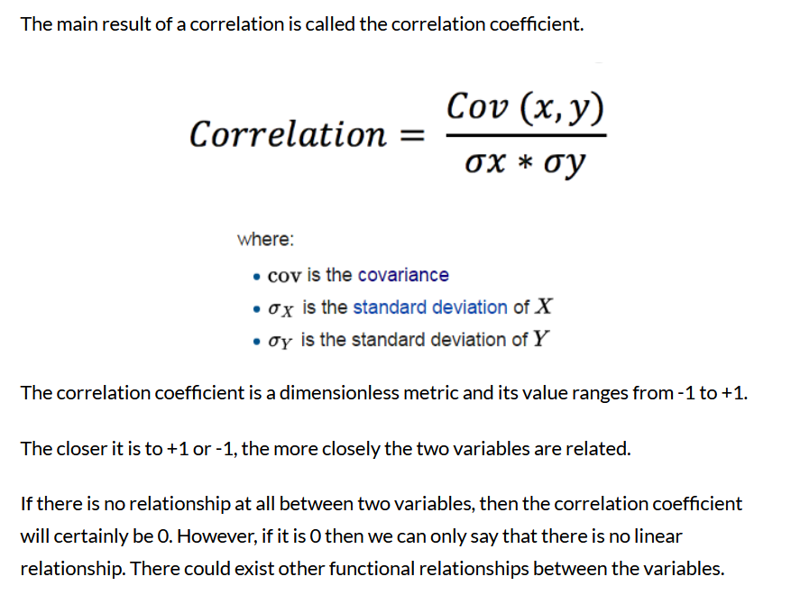

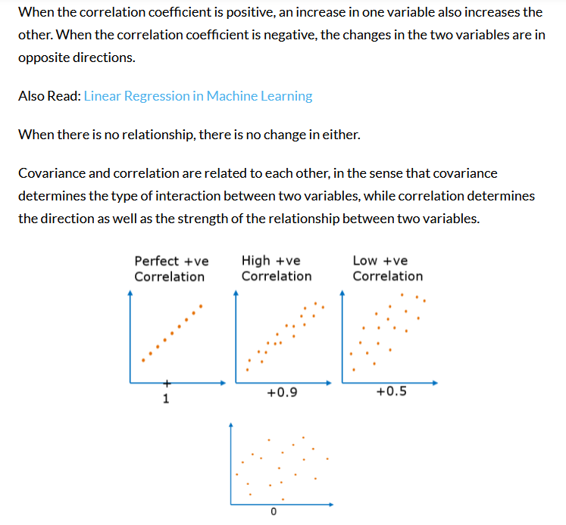

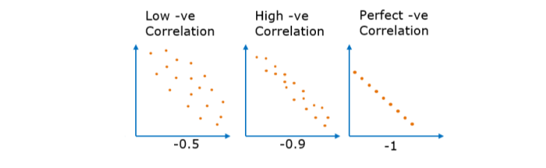

**-ve correlation but extending from -1 to 0**

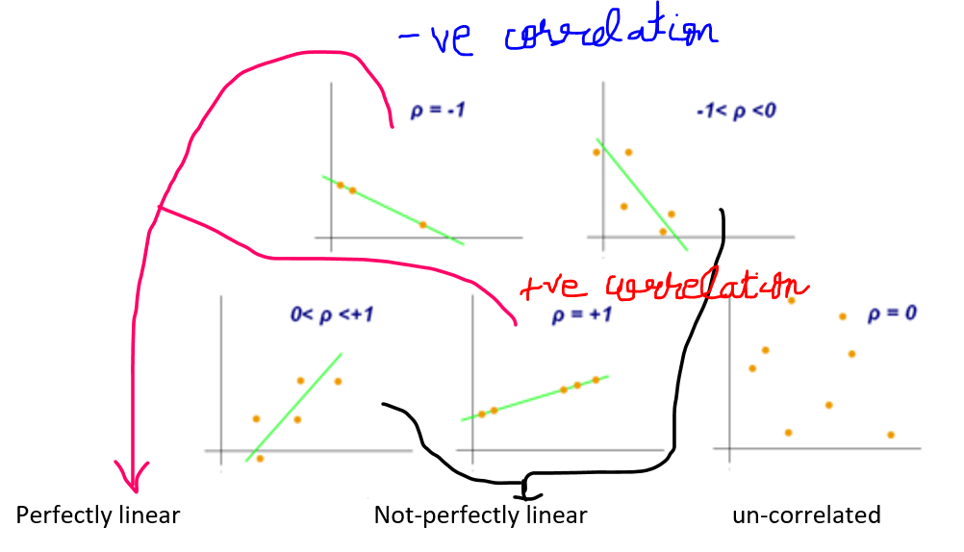



**+ve correlation but extending from 0 to 1**

**Pearson correlation works very well with linear data**

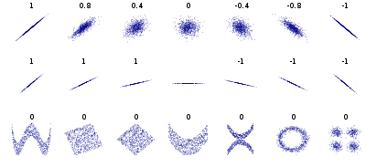

Sign of correlation depends upon the sign of covariance, since standard deviation’s are always +ve.

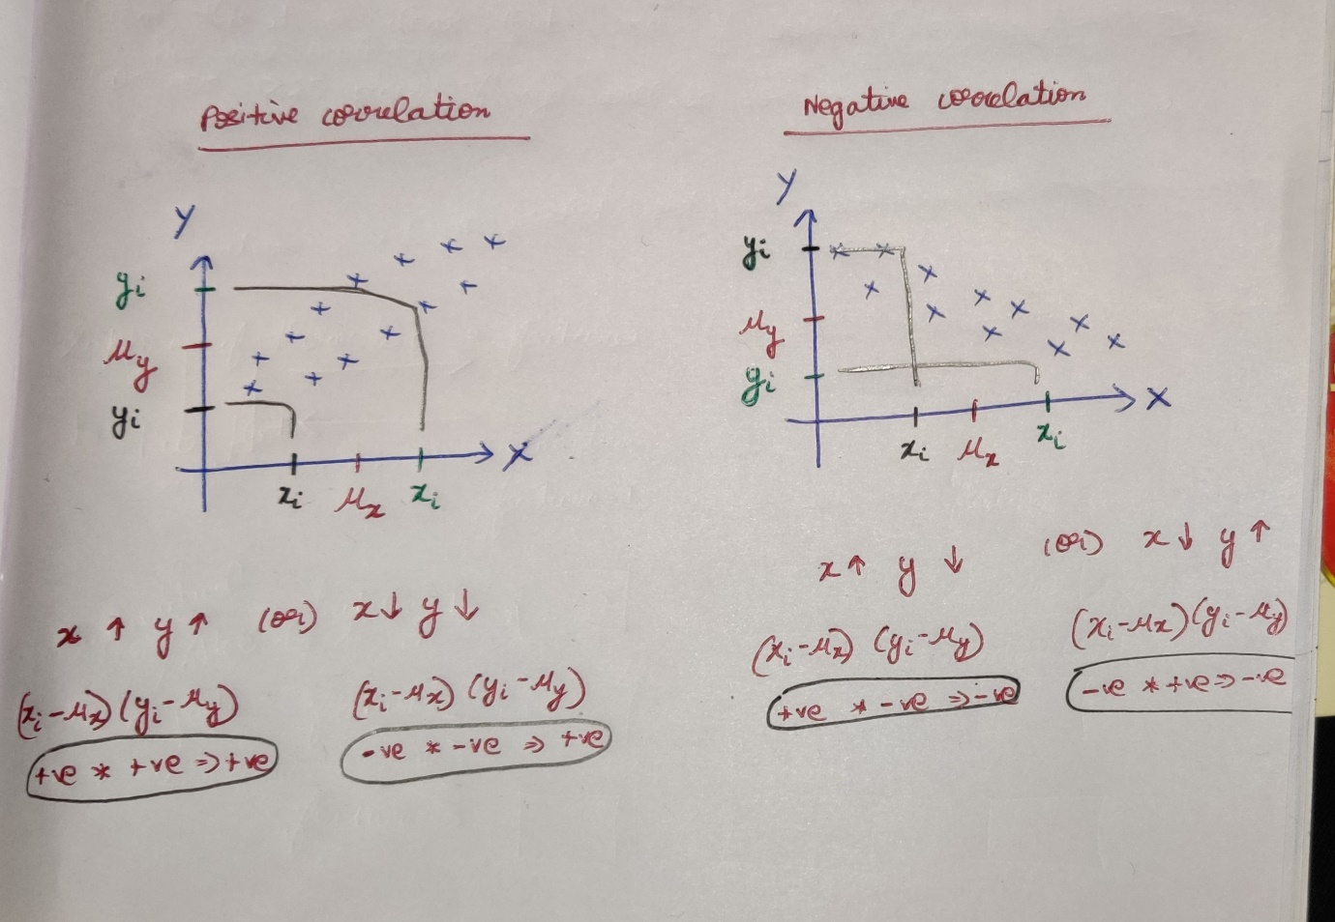

# Difference between covariance and correlation

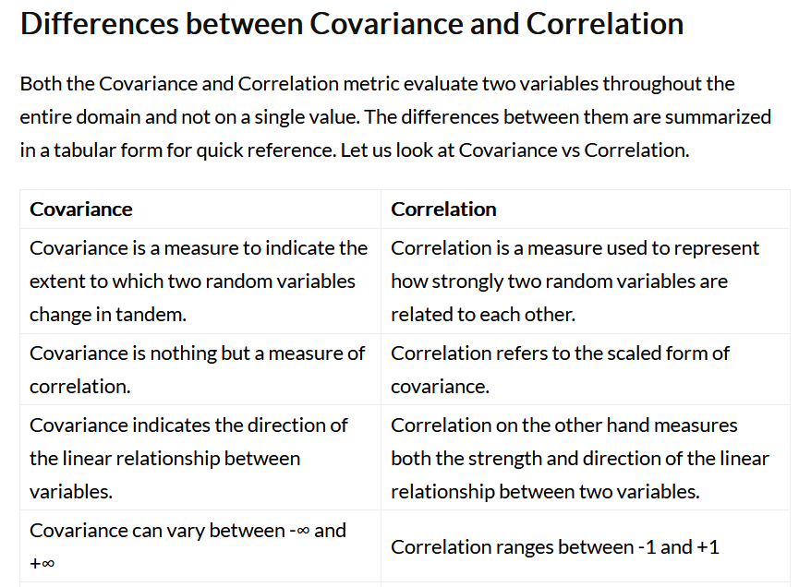



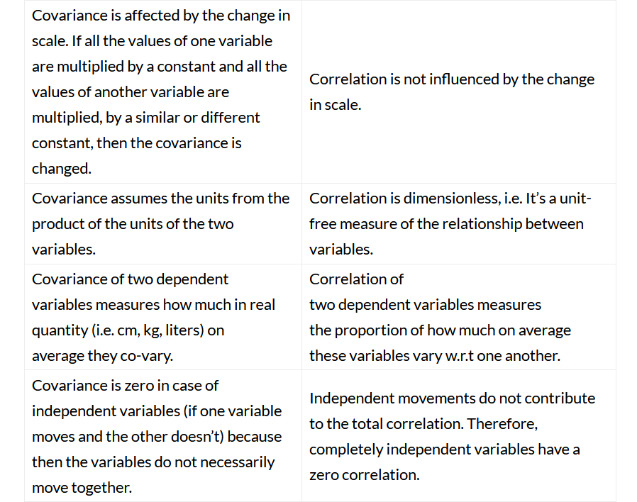

# Spearman rank Correlation

Can also capture the non-linear property also which is not captured in Pearson correlation

***Covariance(-inf to +inf) 🡪 Only direction (+ve direction / -ve direction)  
Pearson Correlation (-1 to +1) 🡪 Magnitude with direction ( how much +ve / how much -ve) and also capture Linear-property  
Spearman correlation (-1 to +1) 🡪 Magnitude with direction ( how much +ve / how much -ve) and also capture the Non-Linear property***

It is Clear that

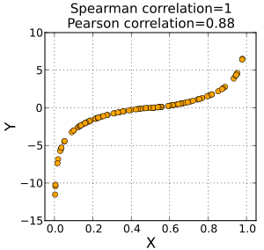

Spearman Rank correlation applied to Pearson’s correlation

